**Stage 8 - “Don’t Forget About That Little Guy”**

**RULES:** USPSA Competition Rules, Latest Edition **COURSE DESIGNER:** Kyle Narkum & Ike Starnes

|  |  |
| --- | --- |
| **START POSITION:** Both feet on the Shooting Sports Innovation Xs, facing downrange.  **Handgun**: Loaded and holstered, wrists below belt. **PCC**: Loaded, stock on belt, muzzle pointed directly downrange. | |
| **STAGE PROCEDURE**  See written stage briefing. | **SCORING**  **SCORING:** Comstock 30 rounds.  **TARGETS:** 14 cardboard targets, 2 steel targets.  **SCORED HITS:** 2 Best hits per carboard will be scored, steel must fall to score.  **START-STOP:**  Audible - Last shot  **PENALTIES:** Per USPSA Competition Rules |

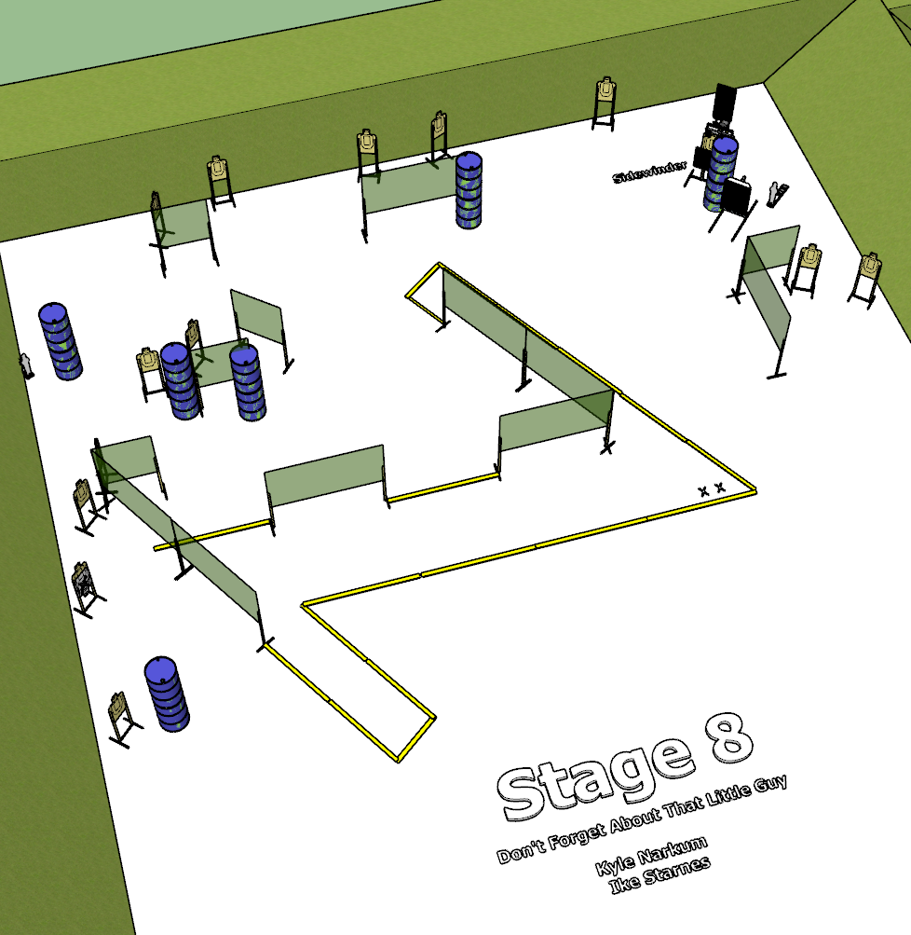

**Written Stage Briefing:**

**Stage 8 - “Don’t Forget About That Little Guy”–** is a 30-round, 150 point, Comstock Long Course. There are 14 cardboard targets and 2 steel targets. The best 2 hits per cardboard target will be scored. The steel must fall to score.

Popper P2 activates the Sidewinder which is visible at rest.

**Start position** Both feet on the Shooting Sports Innovation Xs.

**Handgun**: Loaded and holstered, wrists below belt.

**PCC**: Loaded, stock on belt.

On the audible start signal, engage targets from within the shooting area.

**Setup Notes:**

16 Single Wall Stands

5 Double Wall Stands

8 Full Walls

5 Half Walls

13 Target Stands

26 Target Sticks

1 Sidewinder

2 Mover target sticks

1 Mini Poppers

1 Steel Target Bases

1 Mini Popper Activator + cables

12+ barrels

3 Steel Challenge Plat and bases

1 Starting Xs